
FTP001_V1
Date: 03/02/2020
TECHNICAL DATA SHEET OF ACRYLIC DOORS WITH AGLOMERATED INTERIOR
BUILDING | DOOR TYPE | Interior swing flat door.
BUILDING | PERIMETER FRAME | Spruce pine section 30x25mm (in 35mm blade)
BUILDING | INSIDE | Multilayer wood particle board, bonded together by aminoplast resins with the simultaneous action of pressure and heat, and subsequently subjected to surface sanding.
BUILDING | INTERIOR PROPERTIES | Humidity |  |  |  | EN 322 |  |  |  | 5% - 13%
BUILDING | INTERIOR PROPERTIES | Formaldehyde content |  |  |  | EN 120 |  |  |  | Class E1 (≤8mg/100g)
BUILDING | INTERIOR PROPERTIES | Thick swelling |  |  |  | EN 317 |  |  |  | ≤10%
BUILDING | INTERIOR PROPERTIES | Absorption |  |  |  | EN 317 |  |  |  | ≤50%
BUILDING | PARAMENTS | Medium density fibreboard (650-700 kg / m3) 5 / 7mm thick with a decorative polypropylene-based decorative sheet finish.
BUILDING | EXTERIOR FINISH PROPERTIES | Chemical resistance |  |  | DIN 68861/1 |  |  |  |  |  |  | Class 1C
BUILDING | EXTERIOR FINISH PROPERTIES | Abrasion resistance |  |  | Taber abrasor CS 10 |  |  |  |  |  |  | Min. 400 turns
BUILDING | EXTERIOR FINISH PROPERTIES | Dry heat |  |  | DIN 68861/7 |  |  |  |  |  |  | Class 7C (=100°C)
BUILDING | EXTERIOR FINISH PROPERTIES | Humid heat |  |  | DIN 68861/8 |  |  |  |  |  |  | Class 8C (=100°C)
BUILDING | EXTERIOR FINISH PROPERTIES | Light resistance |  |  | ISO 4892-2 |  |  |  |  |  |  | ≥5
BUILDING | EDGE | 0.8mm thick PVC (variable thickness according to finishes)
MOLDINGS | Swinging material  (when appropriate) | Water-resistant or standard MDF according to request.  Density 650-700kg / m3
MOLDINGS | BATIENTE FINISH  (when appropriate) | Foil finish similar to leaf finishing.
MOLDINGS | PLUG MATERIAL  (when appropriate) | Water-resistant or standard MDF according to request.  Density 650-700kg / m3
MOLDINGS | COVER FINISH  (when appropriate) | Foil finish similar to leaf finishing.
MOLDINGS | CORE MOLD PROPERTIES  (waterproof finish) | Humidity |  |  |  | EN 322 |  |  | 4%-11%
MOLDINGS | CORE MOLD PROPERTIES  (waterproof finish) | Density toleracy |  |  |  | EN 323 |  |  | ±7%
MOLDINGS | CORE MOLD PROPERTIES  (waterproof finish) | Formaldehyde content |  |  |  | EN 120 |  |  | E1 ≤ 8mg/100g
 |  |  |  |  |  |  |  |  | E2 ≤ 30mg/100g
SHEET | CORE MOLD PROPERTIES  S/UNE EN 1529 | Squad | ±1,5mm |  |  |  |  |  |  |  | (class 1)
SHEET | CORE MOLD PROPERTIES  S/UNE EN 1529 | Height and width | ± 2mm |  |  |  |  |  |  |  | (class 1)
SHEET | CORE MOLD PROPERTIES  S/UNE EN 1529 | Thick | ±1,5mm |  |  |  |  |  |  |  | (class 1)
SHEET | PLANITUDE  S/UNE EN 1530 | Warp | ≤4mm |  |  |  |  |  |  |  | (class 3)
SHEET | PLANITUDE  S/UNE EN 1530 | Curvature beams. | ≤4mm |  |  |  |  |  |  |  | (class 3)
SHEET | PLANITUDE  S/UNE EN 1530 | Curvature heads | ≤2mm |  |  |  |  |  |  |  | (class 3)
SHEET | PLANITUDE  S/UNE EN 1530 | Local flatness | ≤0,3mm |  |  |  |  |  |  |  | (class 3)
SHEET | WATER DIVING  S/UNE 56 803 | Swelling |  |  |  |  | 1,2%
SHEET | WATER DIVING  S/UNE 56 803 | Observations |  |  |  |  | No decoupling
SHEET | SCREW STARTING  S/UNE 56 803 | Middle value (≥500N) |  | Results |  |  |  | Paraments: 1144N
SHEET | SCREW STARTING  S/UNE 56 803 | Minimum value (≥500N) |  |  |  |  |  | Edge: 1376N


*See detail of the door on the next page
FTP001_V1
Date: 03/02/2020

TECHNICAL DATA SHEET OF ACRYLIC DOORS WITH AGLOMERATED INTERIOR

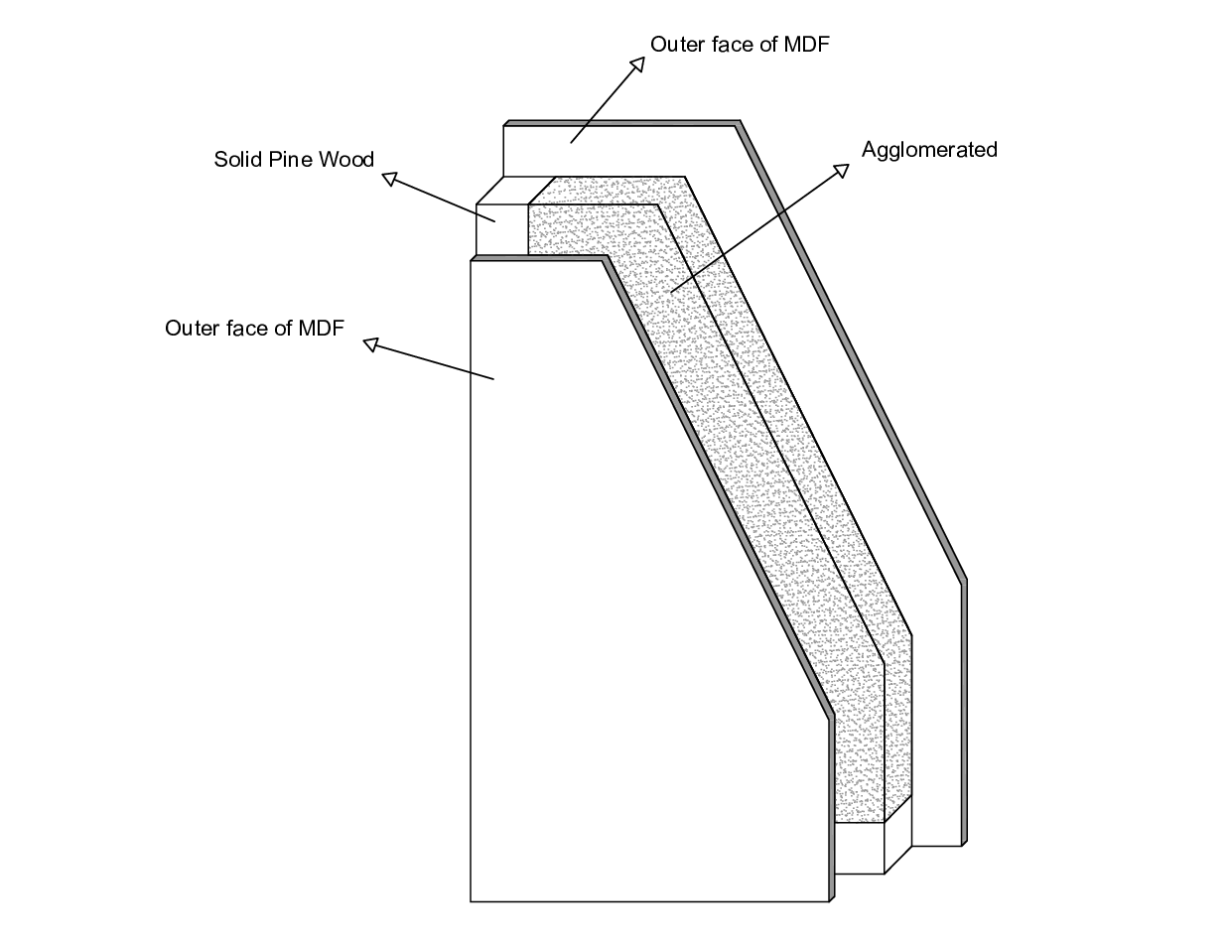


Signed:

Jesús Bejo Santiago
Quality manager

